Task 1: -Create a table listing 3 types of printers, 2 types of scanners, and 2 types of webcams, and for each, write one real-life use case (for example: 'Inkjet printer – printing college assignments').
No. | Device Type | Type | Real-Life Use Case
1 | Printer | Inkjet Printer | Printing college assignments and colour photographs
2 | Printer | Laser Printer | Printing office documents and reports in bulk
3 | Printer | 3D Printer | Creating 3D models and engineering prototypes
4 | Scanner | Flatbed Scanner | Scanning certificates, photographs, and documents
5 | Scanner | Handheld Scanner | Scanning product barcodes in shops
6 | Webcam | Built-in Webcam | Attending online classes on a laptop
7 | Webcam | External USB Webcam | Video conferencing and online meetings on a desktop computer

Task 2: -Draw a labelled diagram showing how a typical home printer connects to a laptop or PC, including the connection interface used (USB, Wi-Fi, or Bluetooth).
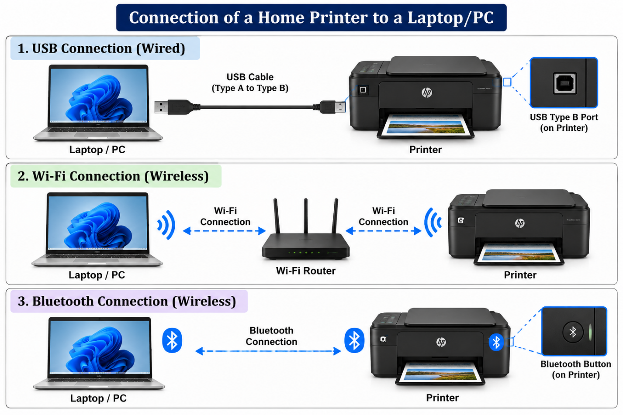

Task 3: -List three different connection interfaces (such as USB, Wi-Fi, Bluetooth) used by peripherals like printers, scanners, and webcams, and for each, name one advantage and one disadvantage. Think about speed, convenience, and compatibility.

 | Point of Difference | USB (wired) | Wi-Fi | Bluetooth
1 | Speed | Very fast: USB 3.x runs at 5-20 Gbps, and USB 2.0 at 480 Mbps | Fast but variable: typically 100 Mbps to 1 Gbps in practice, depending on signal and network load | Slowest: roughly 1-3 Mbps, enough for small files but not large scans or video
2 | Range | Limited by cable length, about 3-5 m without extenders | Good: around 30-50 m indoors, covering a whole home or office | Short: about 10 m for most devices
3 | Ease of setup | Plug and play, with drivers usually installed automatically | More involved: needs network credentials, and sometimes drivers or router settings | Simple pairing, but devices occasionally need re-pairing
4 | Compatibility | Excellent: works with almost all computers, though connector types (A, B, C) can differ | Good: works with any Wi-Fi device, but the printer, scanner or webcam must have Wi-Fi support | Moderate: both ends must support Bluetooth, and few printers, scanners or webcams do
5 | Sharing between users/devices | Usually one computer at a time, unless shared through a network or print server | Excellent: many users and devices can share one printer or scanner | Usually paired with one or two devices at a time
6 | Reliability and interference | Very stable, with little interference | Can drop or slow down with weak signal, congestion or walls | Prone to interference from other wireless devices, and connections can drop
7 | Power | Can power small devices such as webcams through the cable | Needs separate power, and Wi-Fi radios use more battery on portable devices | Low power, ideal for battery-operated portable devices

Task 4: -Pick any one device you use at home or college (printer, scanner, or webcam). Write step-by-step instructions for how you would connect it to your computer, including what cable or wireless method you would use and any setup steps required.
Step-by-Step Instructions
1. Turn on the printer: Connect the printer to a power socket and press the power button.
2. Connect to Wi-Fi: Open the printer's settings menu, select the wireless network option, choose your Wi-Fi network, and enter the password.
3. Connect the computer: Turn on your computer and connect it to the same Wi-Fi network as the printer.
4. Open printer settings: On Windows, go to Settings → Bluetooth & devices → Printers & scanners.
5. Add the printer: Click Add device and wait for Windows to detect the wireless printer.
6. Install the driver: If Windows requests a driver, install it using Windows Update or download the correct driver from the printer manufacturer's official website.
7. Complete the setup: Select the detected printer and follow the on-screen instructions to finish installation.
8. Print a test page: Open a document, press Ctrl + P, select the newly added printer, and click Print to check that it works correctly.
Result: The printer is connected to the computer through Wi-Fi and is ready to print documents wirelessly. No USB cable is required for printing.

